- Recap: In our last session, we learned to give inputs to LLM.Now, here in this session, we’ll learn to work with the output of LLM.

Structured output in Langchain

What’s unstructured output? We give prompt as an input to LLM, for eg, ‘Who is the iron man of India?’ and it gives its response as, ‘Sardar Vallabhbhai Patel is the iron man of India.’ This is an un-structured output because simple texts has no outputs.

What’s structured output? Supose, we gave this prompt as an input ‘Give me a one-day itinerary for Paris.’
- LLMs un-structured response:
Here’s the suggested itinerary.

Morning, visit the Eiffel Tower.
Afternoon, walk through the Louvre Museum.
Enjoy dinner at the Seine riverside café

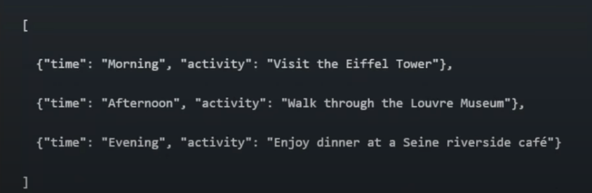
- Json output (This is called structured output):

This structured output is very beneficial, which we’ll learn later. But the biggest advantage is, this structured output can be easily passed from one LLM to other. As a result, we can seemlessly integrate other LLMs with them.

How to get structured output?
There’re two types of LLMs. They’re
- Which can return structured output: Using a function with_structured_output. We can tell this function on which format we want an output and LLM will return output in that particular format.
- Which cannot return structured output: There’re classes in Langchain known as output_parsers using which we can convert un-structured output to structured one.
Today, in this session, we will learn about models which can return structured outputs.

- with_structured_output:
Everything is same, just before calling model.invoke(), we need to call with_structured_output() and pass our desired data format.
- We can specify our desired data format in three ways.
- Typedict
- Pydantic
- Json schema

- Typeddict:
  - In python, we used to create a dictionay. For eg, there’s a dictionary, {‘name: str, ‘age’: int}. Suppose in a project, two programers are working, and one programmer was unaware that ‘age’ should be ‘int’ and he stored ‘str’. This will create issue during runtime.
  - This problem is solved by ‘Typeddict’. It is a class and define that in a dictionary, there’ll be keys name and age which will strore int and str respectively.
  - Now, when we will create a dictionary using this particular class, our code editor will tell us that it should have these keys and these as dtypes.
  - One thing here to note is, it doesn’t force us, we can assign values of any dtype. It’ll just tell us while typing, that this requires particular dtype.
If not understood, see the code.

